

Technical Safety Concept Lane Assistance

**Document Version: 1.0**

**Template Version 1.0, Released on 2017-06-21**



# Document history

|  |  |  |  |
| --- | --- | --- | --- |
| Date | Version | Editor | Description |
| 03/03/2019 | 1.0 | Rangarajan Ramanujam | Initial draft |
|  |  |  |  |
|  |  |  |  |
|  |  |  |  |
|  |  |  |  |

# Table of Contents

Document history

Table of Contents

Purpose of the Technical Safety Concept

Inputs to the Technical Safety Concept

Functional Safety Requirements

Refined System Architecture from Functional Safety Concept

Functional overview of architecture elements

Technical Safety Concept

Technical Safety Requirements

Refinement of the System Architecture

Allocation of Technical Safety Requirements to Architecture Elements

Warning and Degradation Concept

# Purpose of the Technical Safety Concept

This document defines new requirements and assigns it to the system architecture. These requirements are more concrete and gets into details of the item’s technology as specified by ISO 26262.

# Inputs to the Technical Safety Concept

## Functional Safety Requirements

|  |  |  |  |  |
| --- | --- | --- | --- | --- |
| **ID** | **Functional Safety Requirement** | **ASIL** | **Fault Tolerant Time Interval** | **Safe State** |
| Functional  Safety  Requirement  01-01 | |  | | --- | | The lane keeping item shall ensure that the lane departure oscillating torque amplitude is below Max_torque_Amplitude | | C | 50 mS | |  | | --- | | LDW Torque amplitude is set to zero | |
| Functional  Safety  Requirement  01-02 | The lane keeping item shall ensure that the lane departure oscillating torque frequency is below Max_Torque_Frequency | C | 50 mS | LDW Torque amplitude is set to zero |
| Functional  Safety  Requirement  01-03 | The lane keeping item shall ensure that the lane departure oscillating torque will be turned off when the driver is applying more than Max_Driver_Torque_Amplitude | B | 20 mS | LDW Torque amplitude is set to zero |
| Functional  Safety  Requirement  02-01 | The electronic power steering ECU shall ensure that the Lane Keeping Assistance torque is applied only for Max_Duration | B | 500 mS | |  | | --- | | Lane Keeping Assistance Torque is zero | |
| Functional  Safety  Requirement  02-02 | The electronic power steering ECU shall ensure that the Lane Keeping Assistance shall be deactivated under braking conditions | A | 50 mS | Lane Keeping Assistance Torque is zero |

## Refined System Architecture from Functional Safety Concept

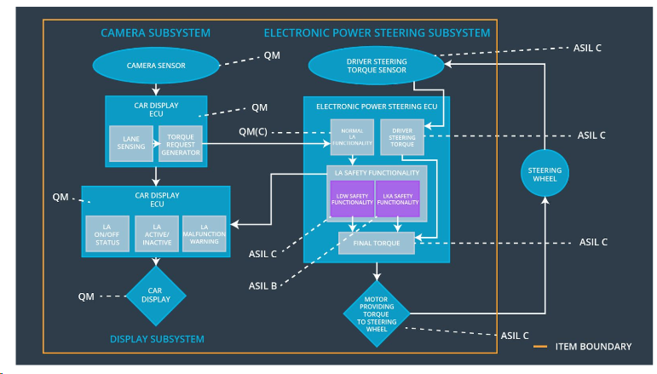

Fig 1: Refined Lane Assistance System Architecture

### Functional overview of architecture elements

|  |  |
| --- | --- |
| **Element** | **Description** |
| Camera Sensor | Capture road images and provide them to the Camera Sensor ECU |
| Camera Sensor ECU - Lane Sensing | Software module detecting the lane line positions from the Camera Sensor images |
| Camera Sensor ECU - Torque request generator | Software module calculating the necessary torque to be requested to the Electronic Power Steering ECU |
| Car Display | Displays warning to the driver |
| Car Display ECU - Lane Assistance On/Off Status | Indicate the status of the Lane Assistance functionality (ON/OFF) |
| Car Display ECU - Lane Assistant Active/Inactive | Indicate if the Lane Assistance functionality is properly functioning (Active/Inactive) |
| Car Display ECU - Lane Assistance malfunction warning | Indicate a malfunction on the Lane Assistance functionality |
| Driver Steering Torque Sensor | Measure the torque applied to the steering wheel by the driver |
| Electronic Power Steering (EPS) ECU - Driver Steering Torque | Software module receiving the driver’s torque request from the steering wheel |
| EPS ECU - Normal Lane Assistance Functionality | Software module receiving the Camera Sensor ECU Torque request |
| EPS ECU - Lane Departure Warning Safety Functionality | Software module ensuring the torque amplitude is below Max_Torque_Amplitude ,torque Frequency is below Max_Torque_Frequency and warning is turned off when the driver input is more than a Max_Driver_Torque_Amplitude |
| EPS ECU - Lane Keeping Assistant Safety Functionality | Software module ensuring the Lane Keeping Assistance functionality application is not active more than Max Duration time and the assistance functionality is turned off during braking conditions. |
| EPS ECU - Final Torque | Combine the torque request from the Lane Keeping and Lane Departure Warning functionalities and sends them to the Motor |
| Motor | Applies the required torque to the steering wheels |

# Technical Safety Concept

## Technical Safety Requirements

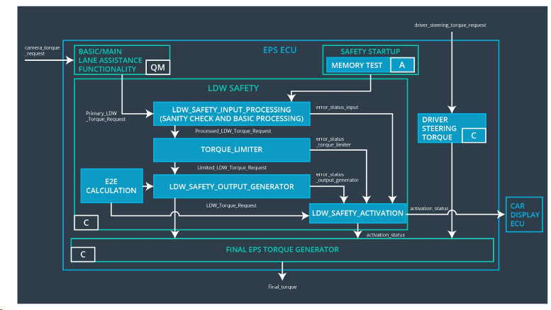Fig 2: Refined Lane Assistance System Architecture

**Lane Departure Warning (LDW) Requirements:**

Functional Safety Requirement 01-01 with its associated system elements

(derived in the functional safety concept)

|  |  |  |  |  |
| --- | --- | --- | --- | --- |
| **ID** | **Functional Safety Requirement** | **Electronic Power Steering ECU** | **Camera ECU** | **Car Display ECU** |
| Functional  Safety  Requirement  01-01 | The lane keeping item shall ensure that the lane departure oscillating torque amplitude is below Max_Torque_Amplitude | X |  |  |

Technical Safety Requirements related to Functional Safety Requirement 01-01 are:

|  |  |  |  |  |  |
| --- | --- | --- | --- | --- | --- |
| **ID** | **Technical Safety Requirement** | **ASIL** | **Fault Tolerant Time Interval** | **Architecture Allocation** | **Safe State** |
| Technical  Safety  Requirement  01 | The Lane Departure Warning safety component shall ensure that the amplitude of the ‘LDW_Torque_Request’ sent to the ‘final electronic power steering Torque’ component is below ‘Max_Torque_Amplitude’ | C | 50 mS | LDW Safety | LDW Torque Request Amplitude shall be set to zero |
| Technical  Safety  Requirement  02 | When the Lane Departure Warning is deactivated, the ‘LDW Safety’ software module shall send a signal to the Car Display ECU to turn on a warning signal | C | 50 mS | LDW Safety | LDW Torque Request Amplitude shall be set to zero |
| Technical  Safety  Requirement  03 | When a failure is detected by the LDW function, it shall deactivate the LDW feature and the ‘LDW_Torque_Request’ shall be set to zero | C | 50 mS | LDW Safety | LDW Torque Request Amplitude shall be set to zero |
| Technical  Safety  Requirement  04 | The validity and integrity of the data transmission for ‘LDW_Torque_Request’ signal shall be ensured | C | 50 mS | LDW Safety | LDW Torque Request Amplitude shall be set to zero |
| Technical  Safety  Requirement  05 | Memory test shall be conducted at startup of the EPS ECU to check for any faults in memory | A | Ignition Cycle | Data Transmission Integrity Check | LDQ Torque Request Amplitude shall be set to zero |

Functional Safety Requirement 01-2 with its associated system elements

(derived in the functional safety concept)

|  |  |  |  |  |
| --- | --- | --- | --- | --- |
| **ID** | **Functional Safety Requirement** | **Electronic Power Steering ECU** | **Camera ECU** | **Car Display ECU** |
| Functional  Safety  Requirement  01-02 | The lane keeping item shall ensure that the lane departure oscillating torque frequency is below Max_Torque_Frequency | X |  |  |

Technical Safety Requirements related to Functional Safety Requirement 01-02 are:

|  |  |  |  |  |  |
| --- | --- | --- | --- | --- | --- |
| **ID** | **Technical Safety Requirement** | **ASIL** | **Fault Tolerant Time Interval** | **Architecture Allocation** | **Safe State** |
| Technical  Safety  Requirement  01 | The LDW Safety component shall ensure that the frequency of the ‘LDW_Torque_Request’ sent to the ‘Final electronic power steering Torque’ component is below ‘Max_Torque_Frequency’ | C | 50 mS | LDW Safety | LDW Torque Request Frequency shall be set to zero |
| Technical  Safety  Requirement  02 | The validity and the integrity of the data transmission for ‘Max_Torque_Frequency’ signal shall be ensured | C | 50 mS | LDW Safety | LDW Torque Request Frequency shall be set to zero |
| Technical  Safety  Requirement  03 | When a failure is detected by the LDW function, it shall deactivate the LDW feature and the ‘Max_Torque_Frequency’ shall be set to zero | C | 50 mS | LDW Safety | LDW Torque Request Frequency shall be set to zero |
| Technical  Safety  Requirement  04 | When the Lane Departure Warning is deactivated, the ‘LDW Safety’ software module shall send a signal to the Car Display ECU to turn on a warning signal | C | 50 mS | LDW Safety | LDW Torque Request Frequency shall be set to zero |
| Technical  Safety  Requirement  05 | Memory test shall be conducted at startup of the EPS ECU to check for any faults in memory | A | Ignition Cycle | Data Transmission Integrity Check | LDW Torque Request Frequency shall be set to zero |

Functional Safety Requirement 01-3 with its associated system elements

(derived in the functional safety concept)

|  |  |  |  |  |
| --- | --- | --- | --- | --- |
| **ID** | **Functional Safety Requirement** | **Electronic Power Steering ECU** | **Camera ECU** | **Car Display ECU** |
| Functional  Safety  Requirement  01-02 | The lane keeping item shall ensure that the lane departure oscillating torque will be turned off when the driver is applying more than Max_Driver_Torque_Amplitude | X |  |  |

Technical Safety Requirements related to Functional Safety Requirement 01-03 are:

|  |  |  |  |  |  |
| --- | --- | --- | --- | --- | --- |
| **ID** | **Technical Safety Requirement** | **ASIL** | **Fault Tolerant Time Interval** | **Architecture Allocation** | **Safe State** |
| Technical  Safety  Requirement  01 | The LDW Safety component shall ensure that the amplitude and frequency of ‘LDW_Torque_Request’ and ‘Max_Torque_Frequency’ shall be set to zero when driver torque input is greater than ‘Max_Driver_Torque_Amplitude’ | B | 20 mS | LDW Safety | LDW Torque Request Amplitude and Frequency shall be set to zero |
| Technical  Safety  Requirement  02 | When the driver torque input is greater than the ‘Max_Driver_Torque_Amplitude’, the ‘LDW Safety’ software module shall send a signal to the Car Display ECU to turn on a ‘LDW_Inactive’ signal | B | 20 mS | LDW Safety | LDW Torque Request Amplitude and Frequency shall be set to zero |
| Technical  Safety  Requirement  03 | Memory test shall be conducted at startup of the EPS ECU to check for any faults in memory | A | Ignition Cycle | Data Transmission Integrity Check | LDW Torque Request Amplitude and Frequency shall be set to zero |

**Lane Keeping Assistance (LKA) Requirements:**

Functional Safety Requirement 02-1 with its associated system elements

(derived in the functional safety concept)

|  |  |  |  |  |
| --- | --- | --- | --- | --- |
| **ID** | **Functional Safety Requirement** | **Electronic Power Steering ECU** | **Camera ECU** | **Car Display ECU** |
| Functional  Safety  Requirement  02-01 | The lane keeping item shall ensure that the lane keeping assistance torque is applied for only Max_Duration | X |  |  |

Technical Safety Requirements related to Functional Safety Requirement 02-01 are:

|  |  |  |  |  |  |
| --- | --- | --- | --- | --- | --- |
| **ID** | **Technical Safety Requirement** | **ASIL** | **Fault Tolerant Time Interval** | **Allocation to Architecture** | **Safe State** |
| Technical  Safety  Requirement  01 | The LKA Safety Component shall ensure the duration of the lane keeping assistance torque is applied for less than ‘Max_Duration’ | B | 500 mS | LKA Safety | Lane Keeping Assistance Torque is set to zero |
| Technical  Safety  Requirement  02 | The validity and integrity of the data transmission for ‘LKA_Torque_Request’ signal shall be ensured | B | 500 mS | LKA Safety | Lane Keeping Assistance Torque is set to zero |
| Technical  Safety  Requirement  03 | As soon as a failure is detected by the LKA function, it shall deactivate the LKA feature and the ‘LKA_Torque_Request’ shall be set to zero | B | 500 mS | LKA Safety | Lane Keeping Assistance Torque is set to zero |
| Technical  Safety  Requirement  04 | When the LKA feature is deactivated, the LKA Safety software block shall send a signal to the car display ECU to turn on a warning light | B | 500 mS | LKA Safety | Lane Keeping Assistance Torque is set to zero |
| Technical  Safety  Requirement  05 | Memory test shall be conducted at startup of the EPS ECU to check for any faults in memory | A | Ignition Cycle | Data Transmission Integrity Check | Lane Keeping Assistance torque is set to zero |

Functional Safety Requirement 02-2 with its associated system elements

(derived in the functional safety concept)

|  |  |  |  |  |
| --- | --- | --- | --- | --- |
| **ID** | **Functional Safety Requirement** | **Electronic Power Steering ECU** | **Camera ECU** | **Car Display ECU** |
| Functional  Safety  Requirement  02-02 | The electronic power steering ECU shall ensure that the Lane Keeping Assistance shall be deactivated under braking conditions | X |  |  |

Technical Safety Requirements related to Functional Safety Requirement 02-02 are:

|  |  |  |  |  |  |
| --- | --- | --- | --- | --- | --- |
| **ID** | **Technical Safety Requirement** | **ASIL** | **Fault Tolerant Time Interval** | **Allocation to Architecture** | **Safe State** |
| Technical  Safety  Requirement  01 | The LKA Safety Component shall ensure the 'LKA_Torque_Request' is set to zero under braking conditions | A | 50 mS | LKA Safety | Lane Keeping Assistance Torque is set to zero |
| Technical  Safety  Requirement  02 | When there is heavy braking conditions, the ‘LKA Safety’ software module shall send a signal to the Car Display ECU to turn on a ‘LKA_Inactive’ signal | A | 50 mS | LKA Safety | Lane Keeping Assistance Torque is set to zero |
| Technical  Safety  Requirement  03 | Memory test shall be conducted at startup of the EPS ECU to check for any faults in memory | A | Ignition Cycle | Data Transmission Integrity Check | Lane Keeping Assistance torque is set to zero |

## Refinement of the System Architecture

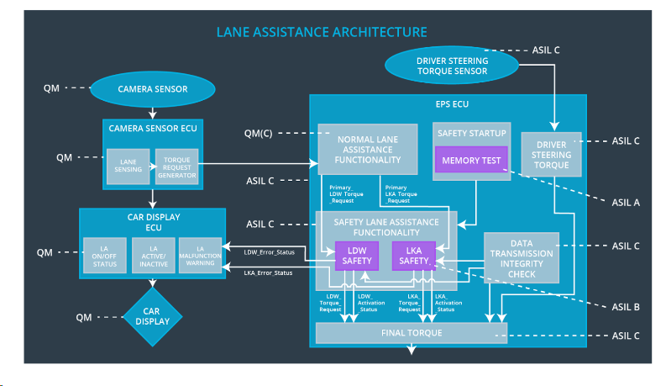

Fig 2: Further Refinement - Lane Assistance Architecture

## Allocation of Technical Safety Requirements to Architecture Elements

|  |  |  |  |  |
| --- | --- | --- | --- | --- |
| **ID** | **Functional Safety Requirement** | **Electronic Power Steering ECU** | **Camera ECU** | **Car Display ECU** |
| Technical Safety  Requirement  01-01-01 | The Lane Departure Warning safety component shall ensure that the amplitude of the ‘LDW_Torque_Request’ sent to the ‘final electronic power steering Torque’ component is below ‘Max_Torque_Amplitude’ | X |  |  |
| Technical  Safety  Requirement  01-01-02 | When the Lane Departure Warning is deactivated, the ‘LDW Safety’ software module shall send a signal to the Car Display ECU to turn on a warning signal | X |  |  |
| Technical  Safety  Requirement  01-01-03 | When a failure is detected by the LDW function, it shall deactivate the LDW feature and the ‘LDW_Torque_Request’ shall be set to zero | X |  |  |
| Technical  Safety  Requirement  01-01-04 | The validity and integrity of the data transmission for ‘LDW_Torque_Request’ signal shall be ensured | X |  |  |
| Technical  Safety  Requirement  01-01-05 | Memory test shall be conducted at startup of the EPS ECU to check for any faults in memory | X |  |  |
| Technical Safety  Requirement  01-02-01 | The LDW Safety component shall ensure that the frequency of the ‘LDW_Torque_Request’ sent to the ‘Final electronic power steering Torque’ component is below ‘Max_Torque_Frequency’ | X |  |  |
| Technical  Safety  Requirement  01-02-02 | The validity and the integrity of the data transmission for ‘Max_Torque_Frequency’ signal shall be ensured | X |  |  |
| Technical  Safety  Requirement  01-02-03 | When a failure is detected by the LDW function, it shall deactivate the LDW feature and the ‘Max_Torque_Frequency’ shall be set to zero | X |  |  |
| Technical  Safety  Requirement  01-02-04 | When the Lane Departure Warning is deactivated, the ‘LDW Safety’ software module shall send a signal to the Car Display ECU to turn on a warning signal | X |  |  |
| Technical  Safety  Requirement  01-02-05 | Memory test shall be conducted at startup of the EPS ECU to check for any faults in memory | X |  |  |
| Technical Safety  Requirement  01-03-01 | The LDW Safety component shall ensure that the amplitude and frequency of ‘LDW_Torque_Request’ and ‘Max_Torque_Frequency’ shall be set to zero when driver torque input is greater than ‘Max_Driver_Torque_Amplitude’ | X |  |  |
| Technical  Safety  Requirement  01-03-02 | When the driver torque input is greater than the ‘Max_Driver_Torque_Amplitude’, the ‘LDW Safety’ software module shall send a signal to the Car Display ECU to turn on a ‘LDW_Inactive’ signal | X |  |  |
| Technical  Safety  Requirement  01-03-04 | Memory test shall be conducted at startup of the EPS ECU to check for any faults in memory | X |  |  |
| Technical Safety  Requirement  02-01-01 | The LKA Safety Component shall ensure the duration of the lane keeping assistance torque is applied for less than ‘Max_Duration’ | X |  |  |
| Technical  Safety  Requirement  02-01-02 | The validity and integrity of the data transmission for ‘LKA_Torque_Request’ signal shall be ensured | X |  |  |
| Technical  Safety  Requirement  02-01-03 | As soon as a failure is detected by the LKA function, it shall deactivate the LKA feature and the ‘LKA_Torque_Request’ shall be set to zero | X |  |  |
| Technical  Safety  Requirement  02-01-04 | When the LKA feature is deactivated, the LKA Safety software block shall send a signal to the car display ECU to turn on a warning light | X |  |  |
| Technical  Safety  Requirement  02-01-05 | Memory test shall be conducted at startup of the EPS ECU to check for any faults in memory | X |  |  |
| TechnicalSafety  Requirement  02-02-01 | The LKA Safety Component shall ensure the 'LKA_Torque_Request' is set to zero under braking conditions | X |  |  |
| Technical  Safety  Requirement  02-02-02 | When there is heavy braking conditions, the ‘LKA Safety’ software module shall send a signal to the Car Display ECU to turn on a ‘LKA_Inactive’ signal | X |  |  |
| Technical  Safety  Requirement  02-02-03 | Memory test shall be conducted at startup of the EPS ECU to check for any faults in memory | X |  |  |

## Warning and Degradation Concept

|  |  |  |  |  |
| --- | --- | --- | --- | --- |
| **ID** | **Degradation Mode** | **Trigger for Degradation Mode** | **Safe State invoked?** | **Driver Warning** |
| WDC-01 | Turn off system | Malfunction_01, Malfunction_02,  Malfunction_05 | Yes | Warning Light on the dashboard |
| WDC-02 | Turn off system | Malfunction 03, Malfunction 04 | Yes | Warning Light on the dashboard |